How do I clear my browser cache?
Instructions below for Chrome, Firefox, Edge, and Safari browsers. As Microsoft no longer supports security updates for the Internet Explorer, please do not use Internet Explorer to access Citywide applications.

Please contact your Department IT staff if you need assistance clearing your cache or installing Firefox or Chrome.

Google Chrome
- Open your Chrome browser and click the menu (3 dots) in the top right corner

- Select More tools
- Click Clear browsing data (or use the keyboard shortcut Ctrl+Shift+Del to jump straight to step 4)

- Click Advanced
- For Time range, select All time
- Select all items to ensure all data and files are cleared
- Click Clear data
- Under Privacy and security, click Site Settings
- Click Cookies and site data
- Turn on Clear cookies and site data when you quit Chrome to ensure your cache is cleared after each browser session

New tab
Zoom
100% +
Print...
Cast...
Find... More tools
Ctrl+P
Ctrl+F
Save page as...
►
Edit
Cut
Copy
Paste
Settings
Help
►
Exit

ltJ Managed by your organization
Create shortcut...
8
Clear browsing data... Extensions
Task manager
Ctrt+Shift+Del
Shift+Esc
Developer tools
Ctrl+Shift+I
* f1 PJ 0 | 0  Ctrl+T
New window | Ctrl+N
New incognito window | Ctrl+Shift+N
History |  | ►
Downloads | Ctrl+J
Bookmarks |  | ►

Clear browsing data
0

Basic Advanced

Time rang,e.. _A-11-tim_e_llll!!!!!!!!!!!!!!!!!!!!!!!!!!!!!!!!!!!!!!!!!!!!!!.._. Ia
....

Browsing history None
m
Download history None
m
Cookies and other site data From 1 site
m
Cached images and files Less than 1 MB
m
Passwords and other sign-in data None
m
Autoflll form data None
m
Site Settings None
m

Hosted app data
m
2 apps (Cloud Print, Web store)
- Cancel Clear data

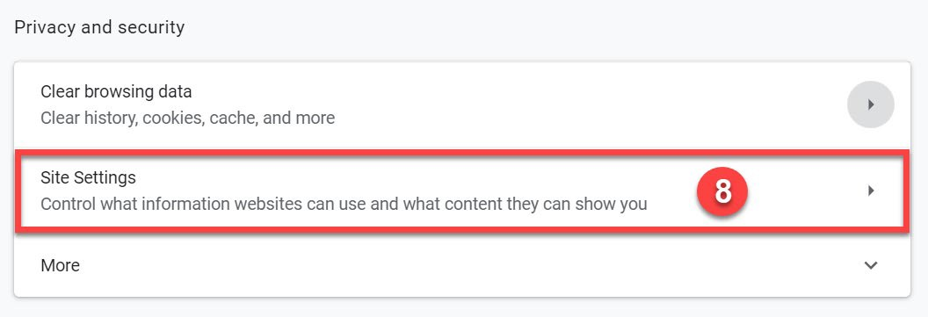
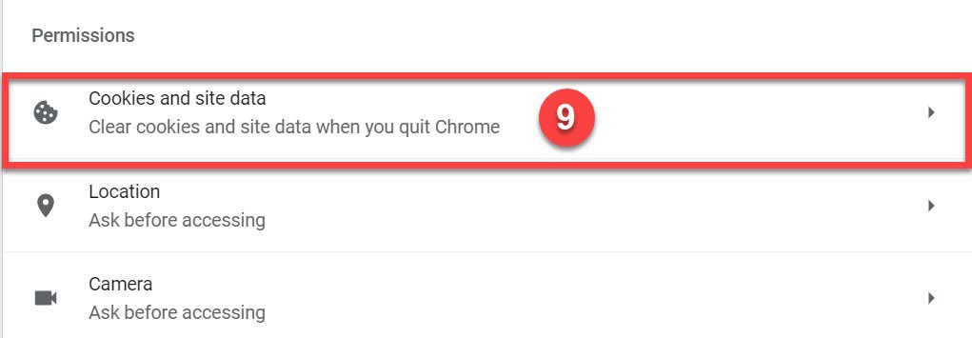
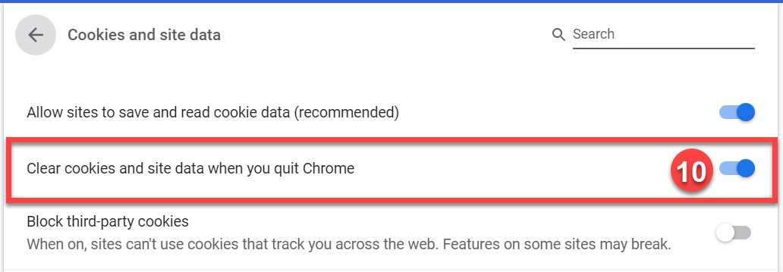

Firefox
- Open your Firefox browser and click the menu in the top right corner

- Click Options (or Preferences)

- Click Privacy & Security
- Under "Cookies and Site Data” click Clear Data…

Check Cookies and Site Data and Cached Web Content
- Click Clear

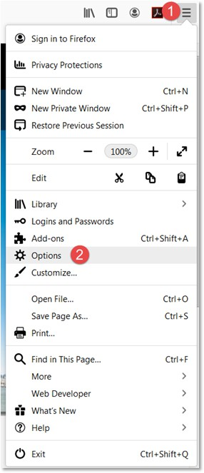

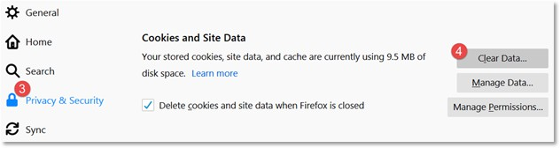

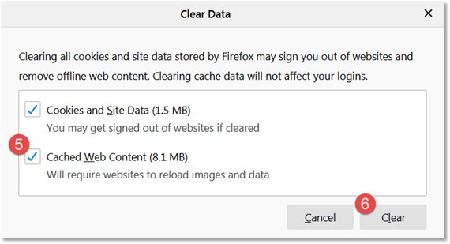

Microsoft Edge
- Open your Edge browser and click the menu (3 dots) in the top right corner
- Click History
- Click Clear History

Check Browsing History, Cookies and saved website data, Cached data and files, Tabs I've set aside or recently closed, and Download history
- Click Clear
- Turn on Always clear this when I close the browser to ensure all data and files are cleared after each browser session.

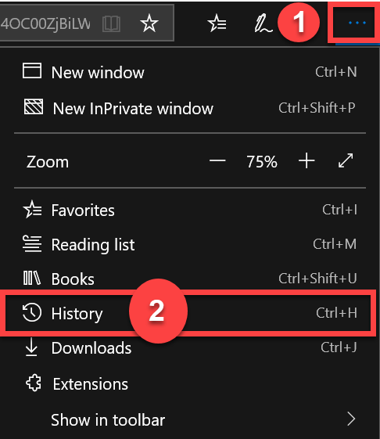


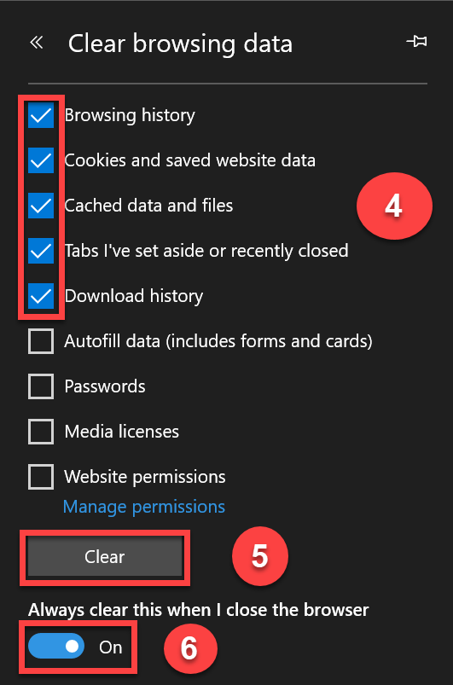

Safari
- Open your Safari browser and click the Safari drop down in the menu bar
- Click Preferences
- Click the Advanced icon

Select Show Develop menu in the menu bar
- Navigate back to Safari and click Develop in the menu bar
- Click Empty Caches
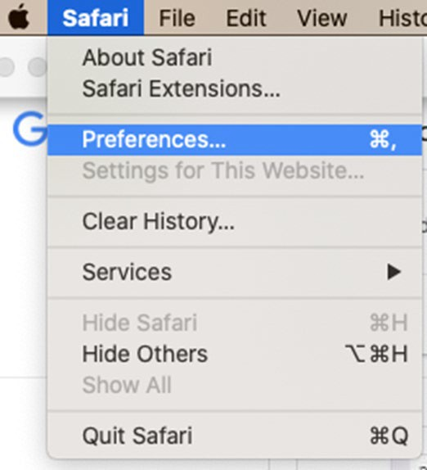

�CJ j

Advanced


General Tabs AutoFill Passwords Search Security Privacy Websites Extensions Advanced

Smart Search Field:

Accessibility:

Reading list:
Show full website address

Never use font sizes smaller than
Press Tab to highlight each item on a webpage
Option-Tab highlights each item.

Save articles for offline reading automatically

Internet plug-ins: D Stop plug-ins to save power

Style sheet: None Selected _B

Default encoding: Western (ISO Latin1) B
Proxies: Change Settings...

D Show Develop menu in menu bar ?

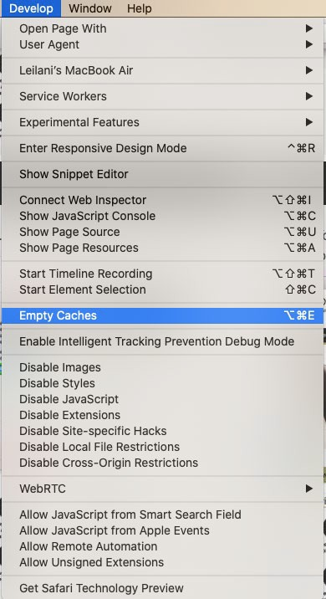

Safari on iPhone
- Open your iPhone Settings
- Click on Safari

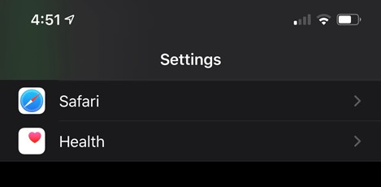
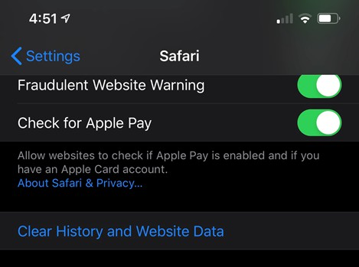
- Click on Clear History and Website Data
- Click on Clear History and Data

